目 录
CloudRC AdvenX3

CloudRC Adven X3 遥控一体机

Product Overview

产品概述

Physical connection

硬件连接

Parameter Configuration

参数配置

Quick Use

快速使用

How to Drive Personal Vehicles with a Steering Whe

如何使用方向盘、手柄、RC遥控器驾驶个人车辆

Advanced Configuration Management

高级配置管理

Others

如何驾驶共享车辆

CloudRC AdvenX3

CloudRC Adven X3 All In One RcCar FPV Remote Controller
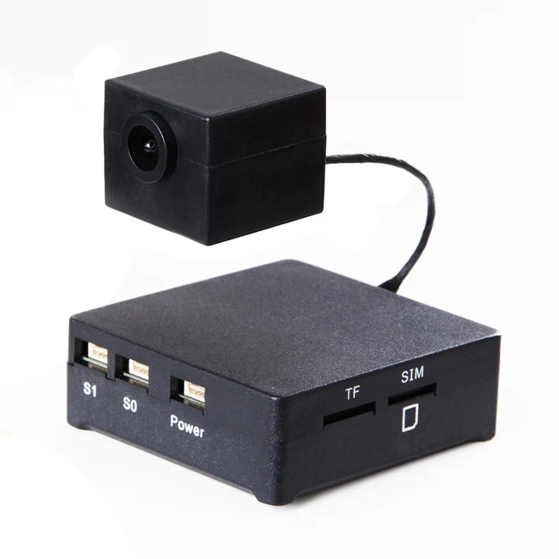
CloudRC Adven X3 Bring you a completely different RC model entertainment experience.By installing AdvenX3, your RC model can be control from an unlimited range of first person views.

CloudRC Adven X3 遥控一体机

CloudRC Adven X3 All In One RcCar FPV Remote Controller
CloudRC Adven X3 Bring you a completely different RC model entertainment experience.By installing AdvenX3, your RC model can be control from an unlimited range of first person views.

Product Overview
CloudRC AdvenX3
Product Number
SHJ-Adv_X3
Usage Scenarios
- It is mainly used for the modification of RC remote control cars, RC remote control boats, RC engineering vehicles, and other RC model-related products.
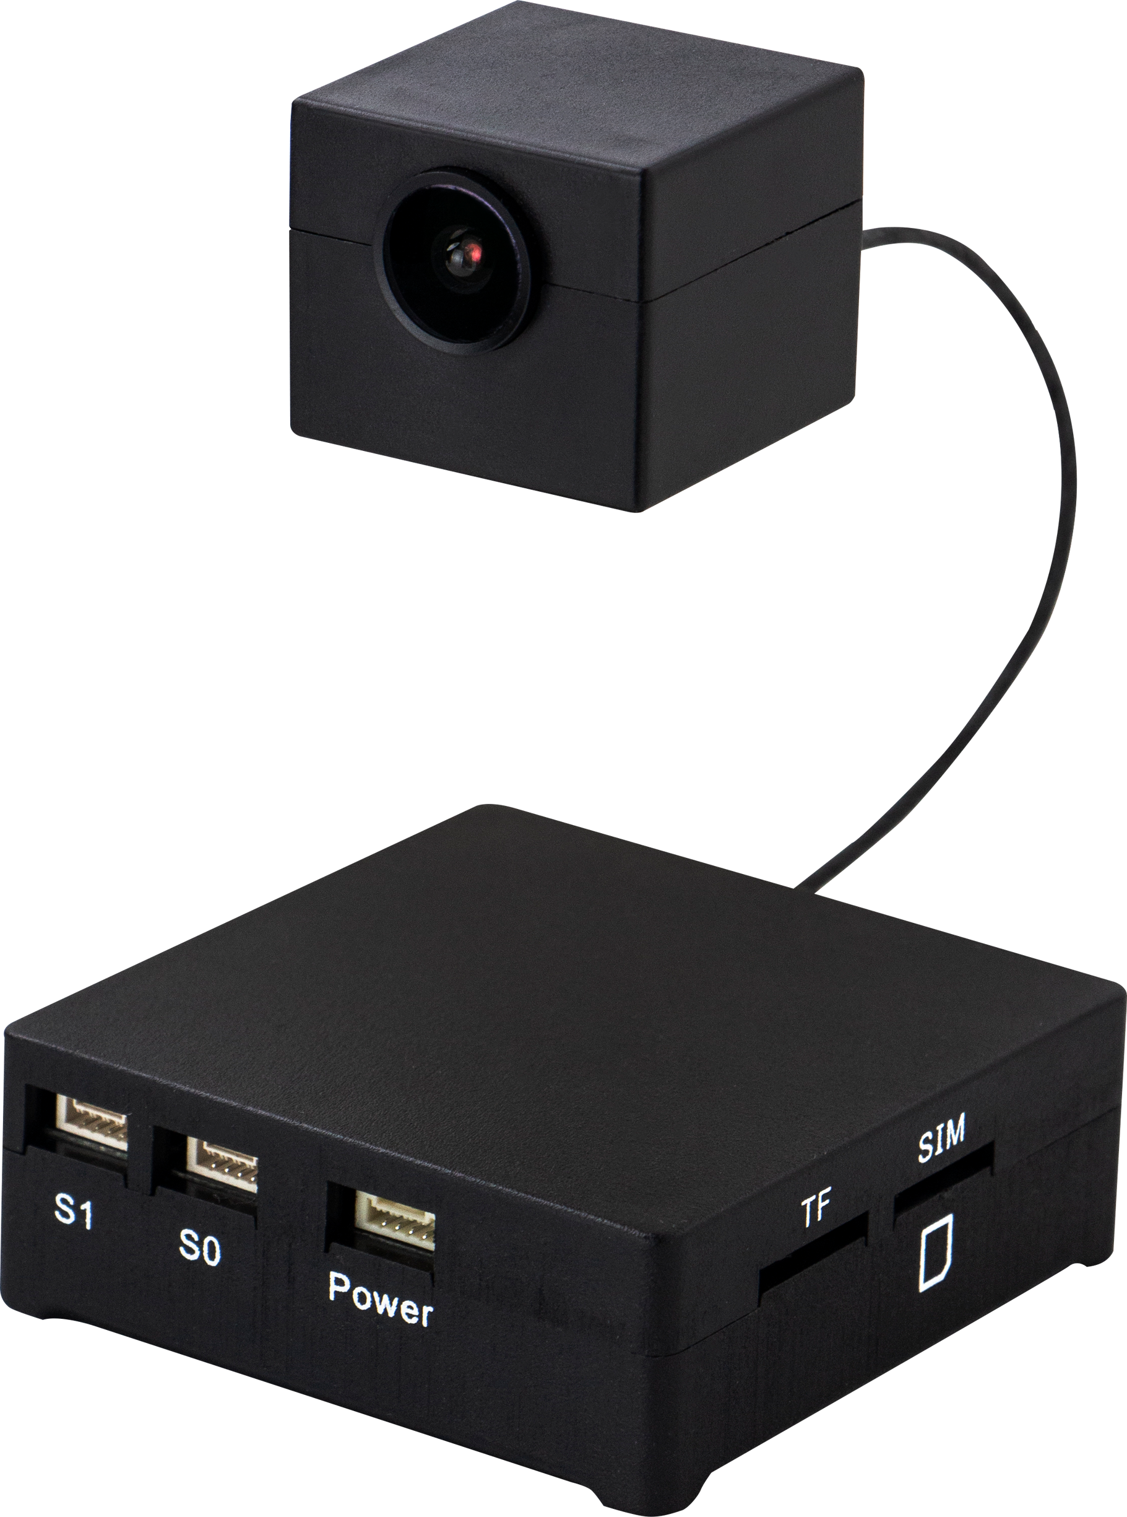

产品概述
CloudRC AdvenX3
产品编号
SHJ-Adv_X3
使用场景
- 主要用于RC遥控车车、RC遥控车船、RC工程车、等RC模型相关产品的改装。

Physical connection
Physical connection
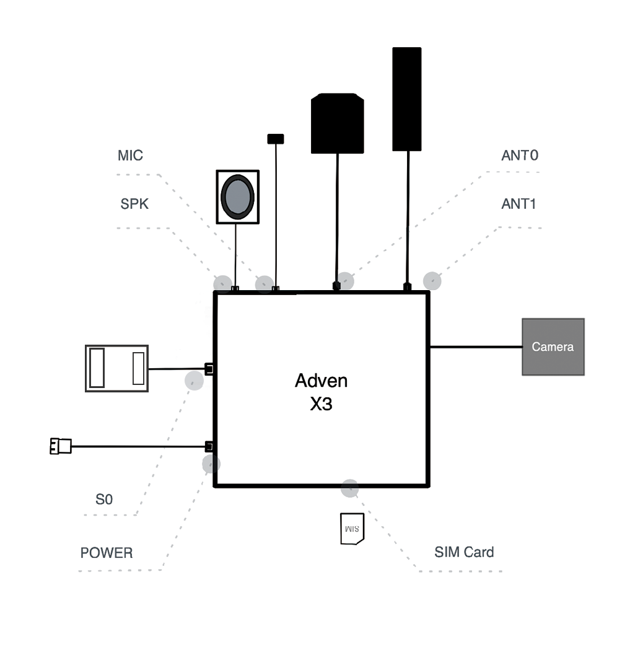

S0: Serial port 0. This is typically used for connecting to external devices or modules using a serial communication protocol. It's often used for data transfer.
POWER: Power input. This is where the main power supply is connected to provide the necessary voltage to operate the device.
SIM Card: Subscriber Identity Module card. This is a small removable card that stores the subscriber's identification information, used for cellular networks.
ANT0: Antenna GPS.
ANT1: Antenna LTE.
SPK: Speaker. This is the audio output device used to produce sound.
MIC: Microphone. This is the audio input device used to capture sound.

硬件连接
硬件连接

Parameter Configuration
- Usage Scenarios
Primarily used for the modification of RC remote control cars, RC remote control boats, RC engineering vehicles, and other related RC model products.
- Basic Parameters
Project | Specifications | Remarks
Supply Voltage | DC 6.0V~18.0V
Device Power Consumption | 2.5w | Typical Value
4G Network | China Mobile  China Unicom  China Telecom
Video Clarity | Ultra HD  HD (High Definition)  SD (Standard Definition)  Smooth
Modes of Access | 4G/WIFI/5G/Dedicated Network | Standard Configuration 4G
Communication Interface 1 | GH1.25-4P | Connect to the Receiver
Communication Interface 2 | GH1.25-4P | Extended Communication (Reserved)
Mic Jack | GH1.25-2P
Speaker Connector | GH1.25-2P
Power Interface | GH1.25-4P
4G Antenna Interface | SMA | External Thread with Internal Hole
GPS Antenna Interface | SMA | External Thread with Internal Hole
SIM Card Slot | Micro SIM Card Slot
Indicator Light | - Power Indicator Light  - Network Indicator  - Function Indicator Light
Working Environment Issues | -10℃~60℃ | Customizable
Prompt | Parameters may be adjusted with the release of new versions,  please be aware; for more product parameters,  please refer to the product manual.

Product Specifications
Project | Specifications | Notes
Weight | 93g | With Lens
Main Unit Dimensions | 65mm x 72mm x 23mm
Lens Dimensions | 32mm x 33mm x 26mm
Tip | Parameters are manually measured and may have errors

参数配置
- 使用场景
主要用于RC遥控车车、RC遥控车船、RC工程车、等RC模型相关产品的改装。
- 基本参数
项目 | 规格指标 | 备注
供电电压 | DC 6.0V~18.0V
设备功耗 | 2.5w | 典型值
4G网络 | 移动/联通/电信
视频清晰度 | 超清/高清/标清/流畅
入网方式 | 4G/WIFI/5G/专网 | 标配4G
通信接口1 | GH1.25-4P | 连接接收机
通信接口2 | GH1.25-4P | 扩展通信(预留
麦克接口 | GH1.25-2P
喇叭接口 | GH1.25-2P
电源接口 | GH1.25-4P
4G天线接口 | SMA | 外螺内孔
GPS天线接口 | SMA | 外螺内孔
SIM卡插槽 | Micro SIM卡插槽
指示灯 | 电源指示灯、网络指示、功能指示灯
工作环境问题 | -10℃~60℃ | 可定制
提示 | 参数可能会因新版本发布有所调整，  请悉知；更多产品参数请查看产品手册。

产品规格
项目 | 规格指标 | 备注
重量 | 93g | 含镜头
主机尺寸 | 65mm x 72mm x 23mm
镜头尺寸 | 32mm x 33mm x 26mm
提示 | 参数为手工测量，存在误差。

Quick Use
1. Download the CloudRC APP from the Google Play Store or Apple App Store.
2. Log in to your CloudRC APP account or register a new one, and then log in. Click on the Active button in the top right corner to jump to the Adven Activate interface and scan the QR code of the integrated machine to bind the vehicle.
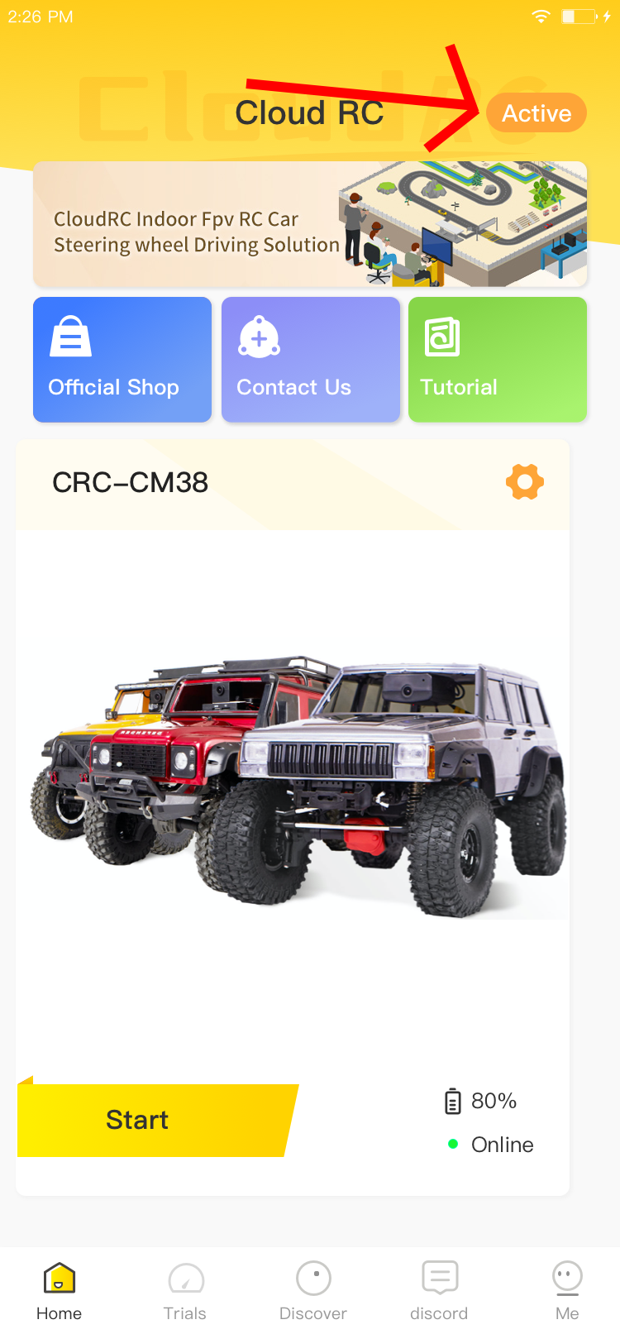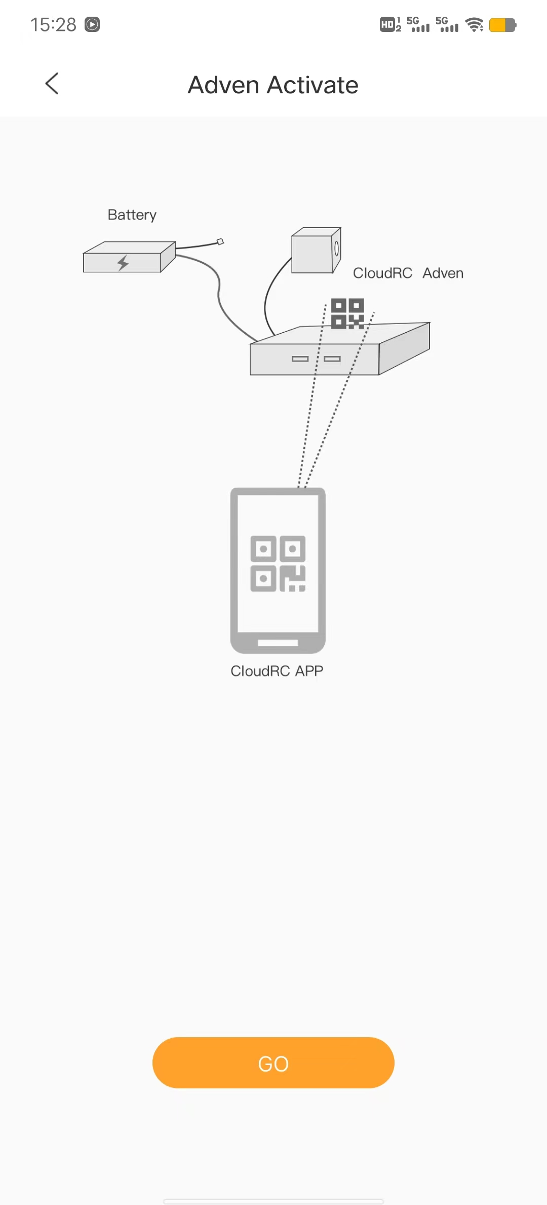
3. On the home page, click Start to enter the driving interface.
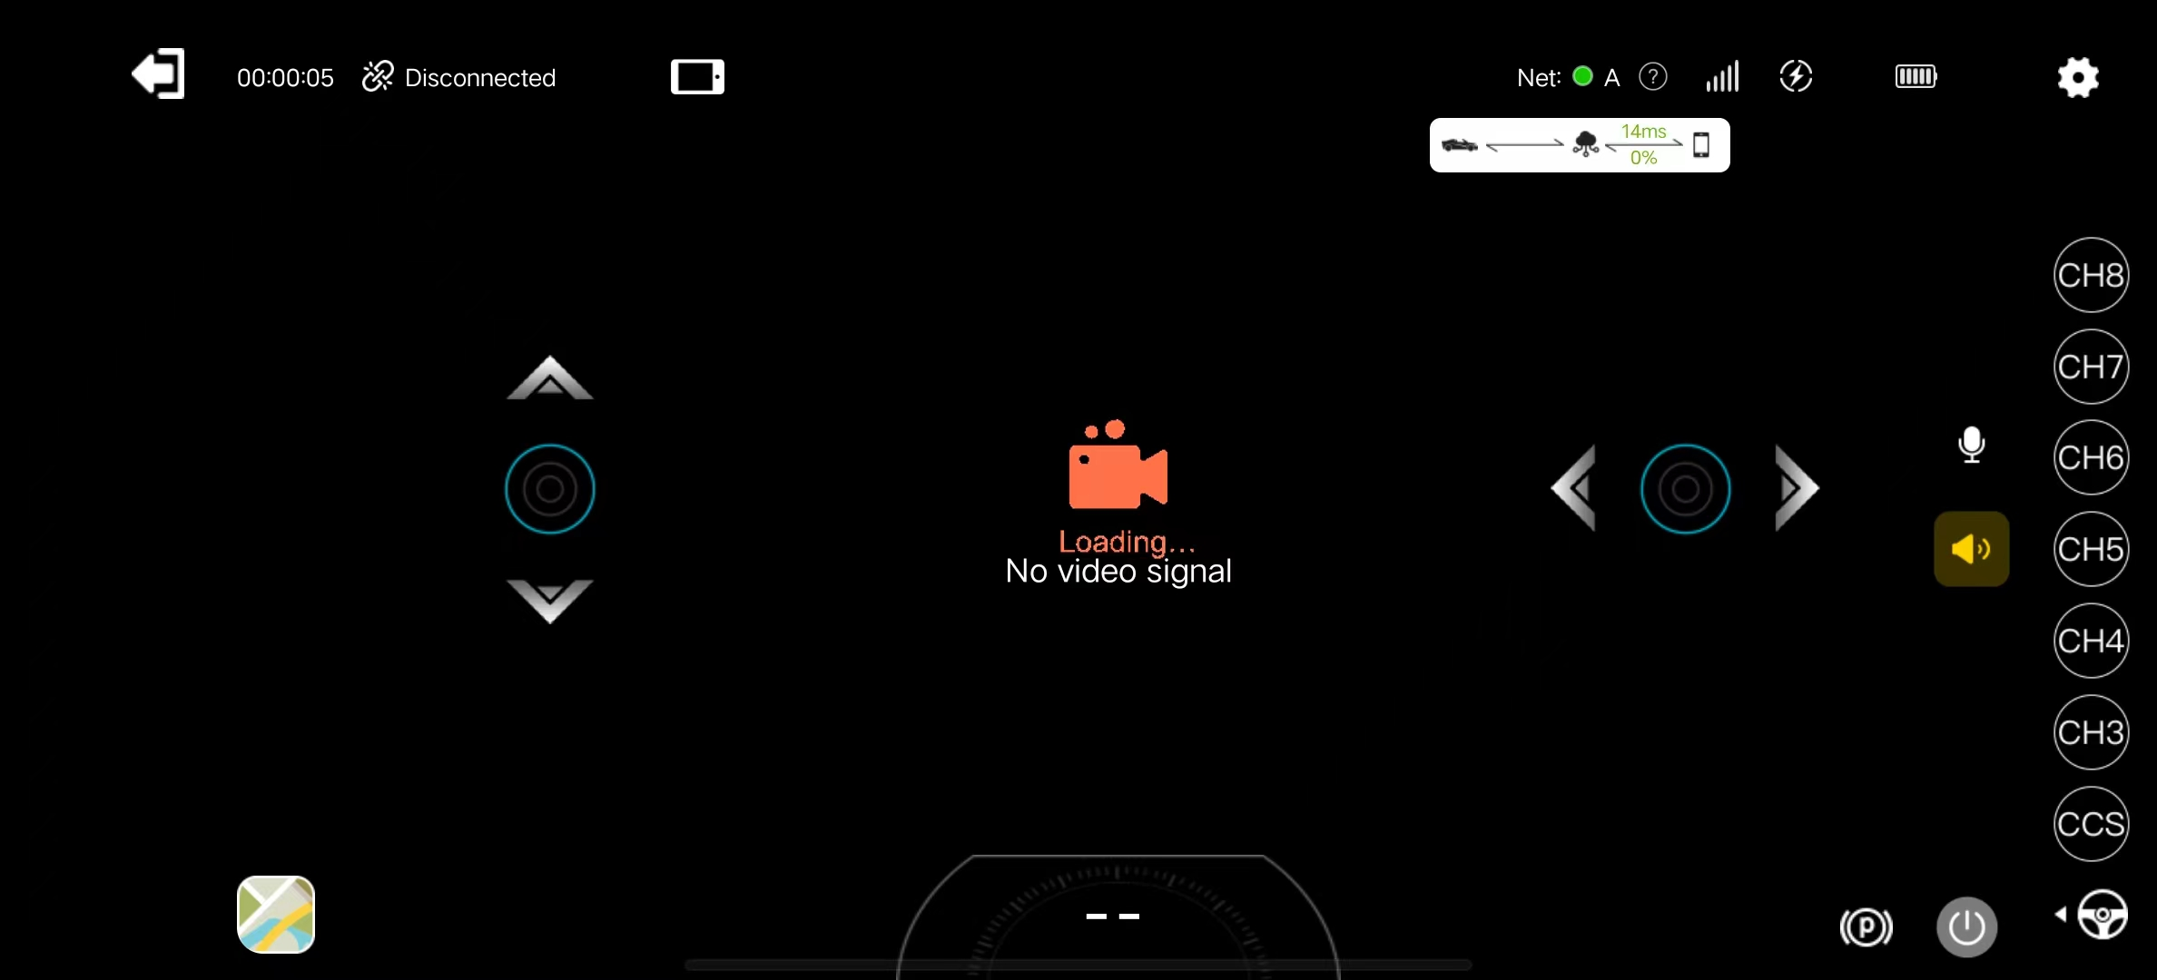

快速使用
1、从谷歌下载CloudRC APP Play商店或苹果应用商店
2、登录或者注册CloudRC APP账号，并登录，点击右上角Active，跳转到Adven Activate界面扫描一体机二维码绑定车辆

3、首页点击 Start 进入驾驶界面

How to Drive Personal Vehicles with a Steering Whe
1. Enter the driving page and click on the settings in the top right corner to enter the remote control mode.
You can choose from APP Remote Control Mode, Remote Controller Mode, or Gamepad Mode.
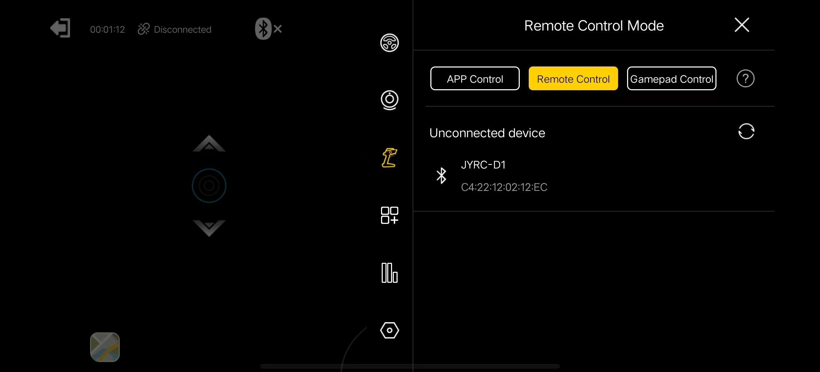

如何使用方向盘、手柄、RC遥控器驾驶个人车辆
1、进入驾驶页，点击右上角设置，进入遥控模式
可选择 APP 遥控模式、遥控器遥控模式、游戏手柄模式

Advanced Configuration Management

高级配置管理
Advanced Configuration Management
Control Parameter Settings
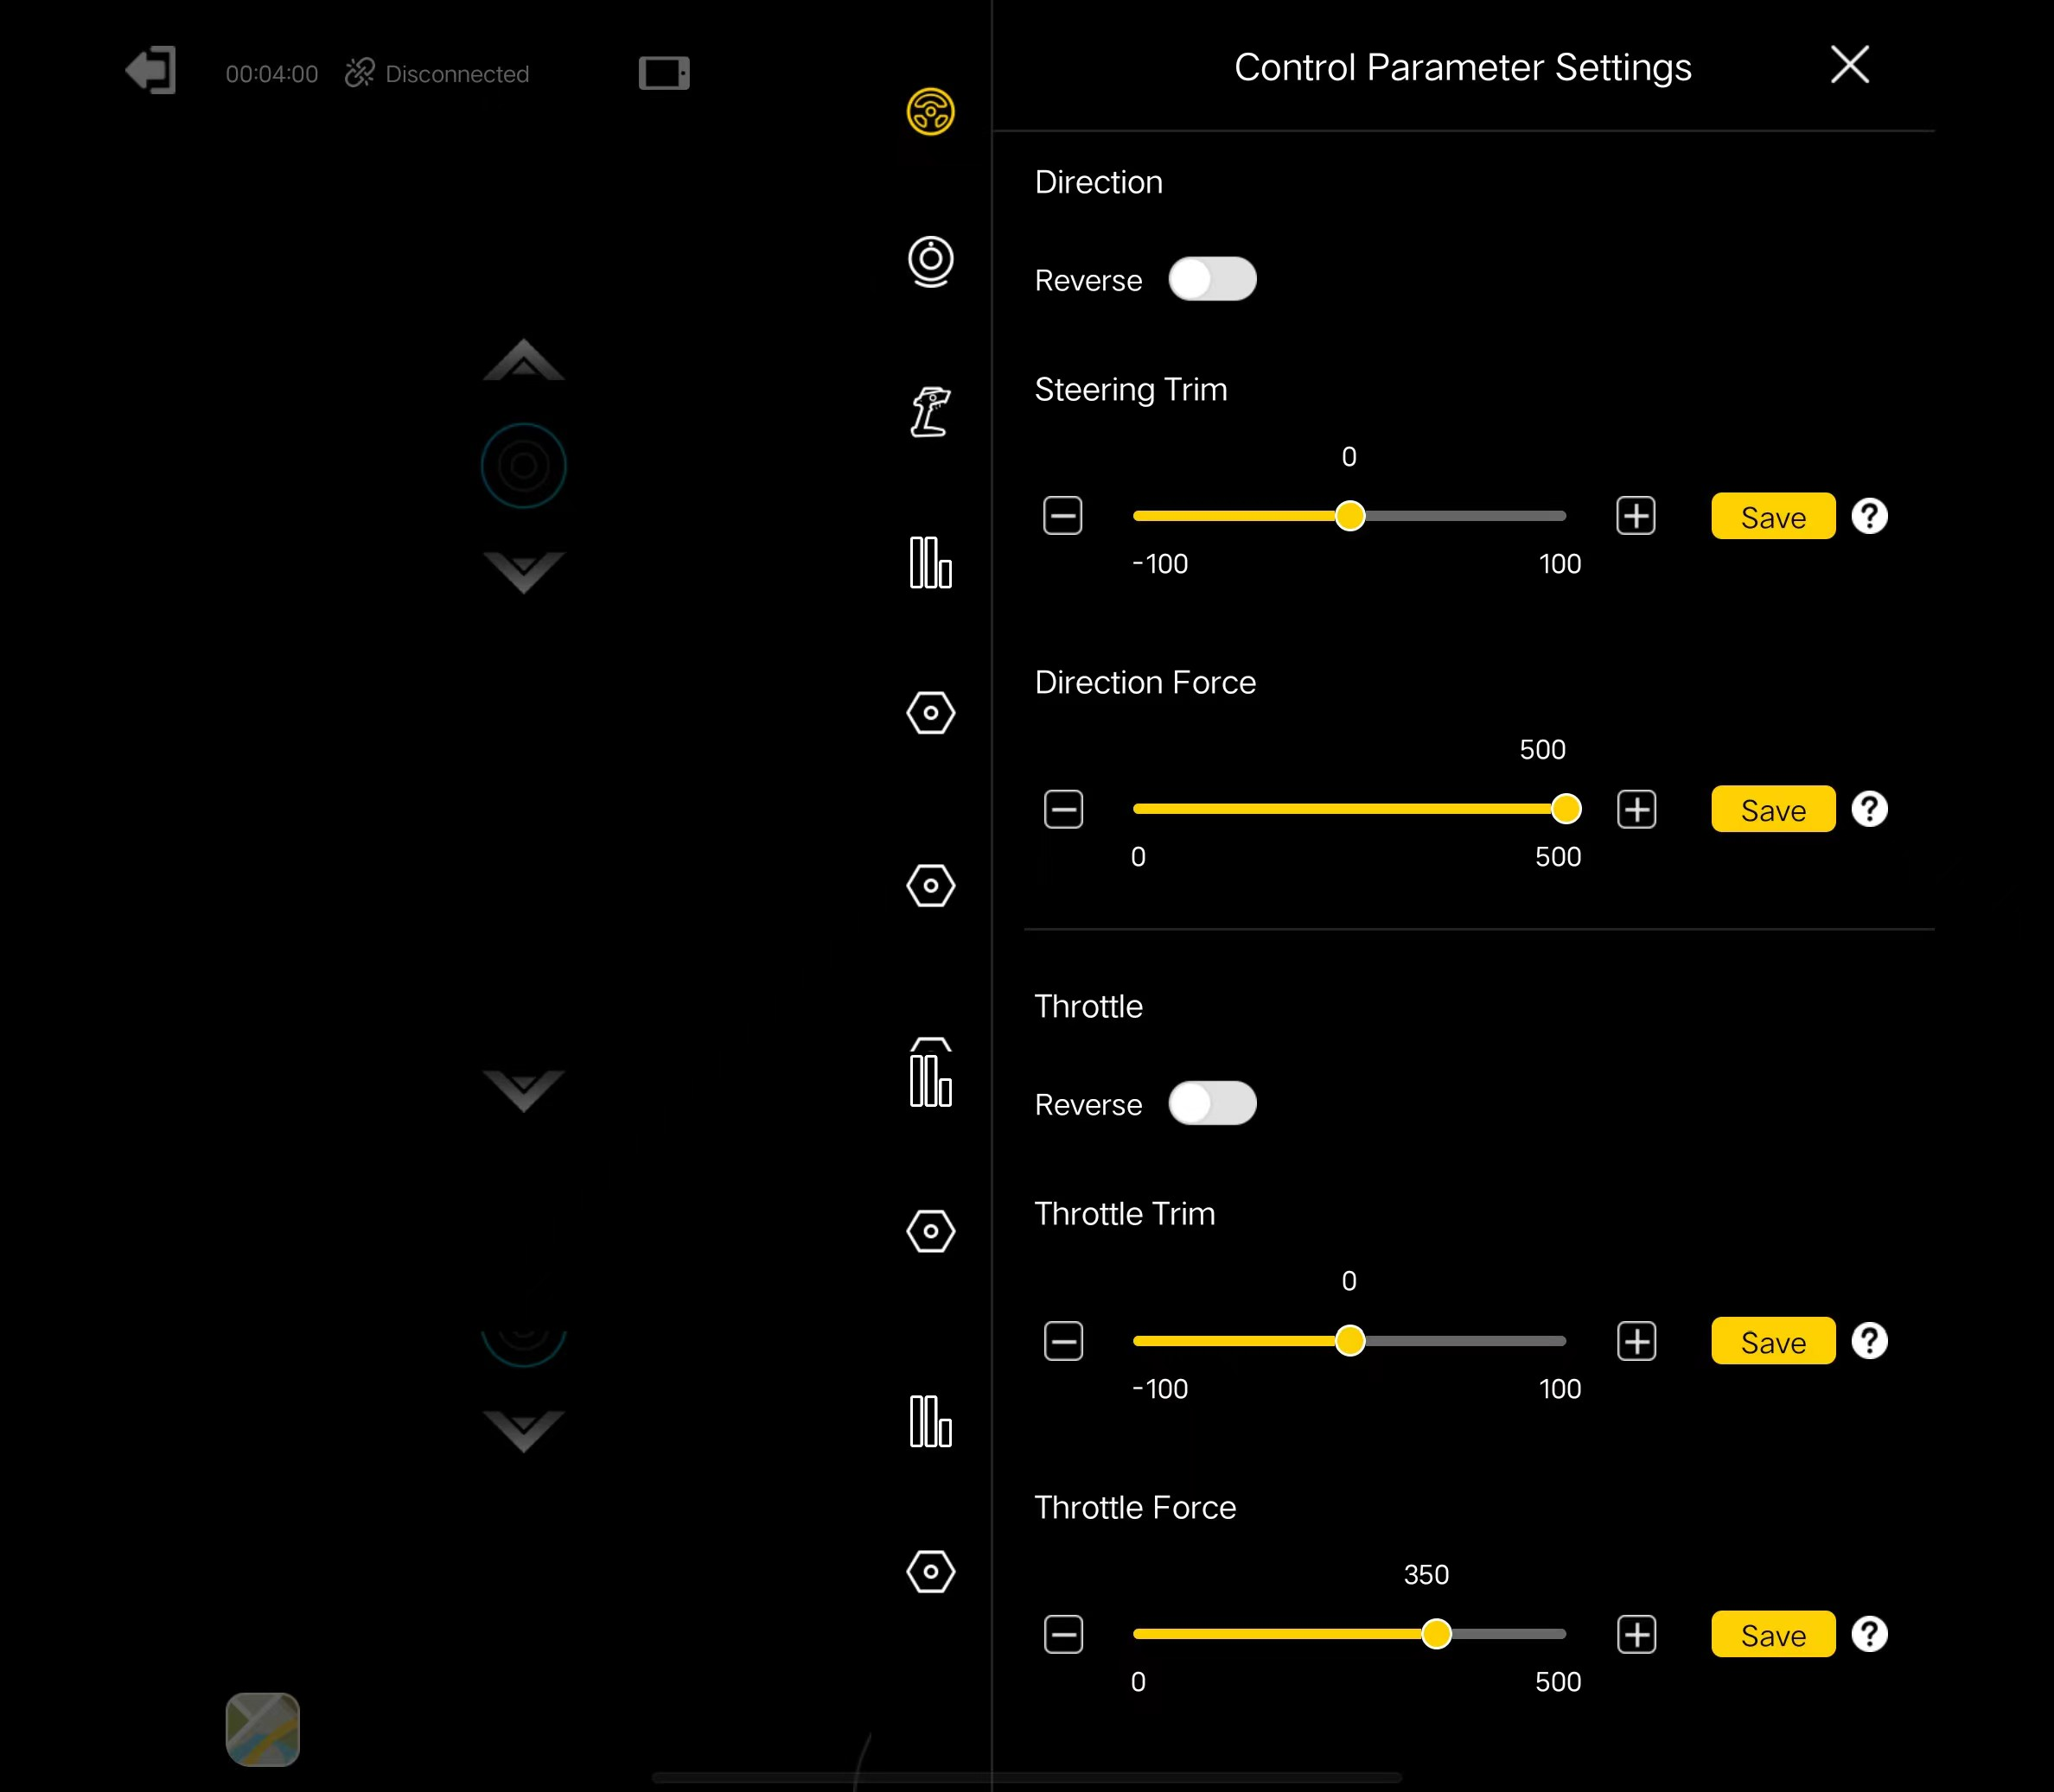

Audio and Video Settings
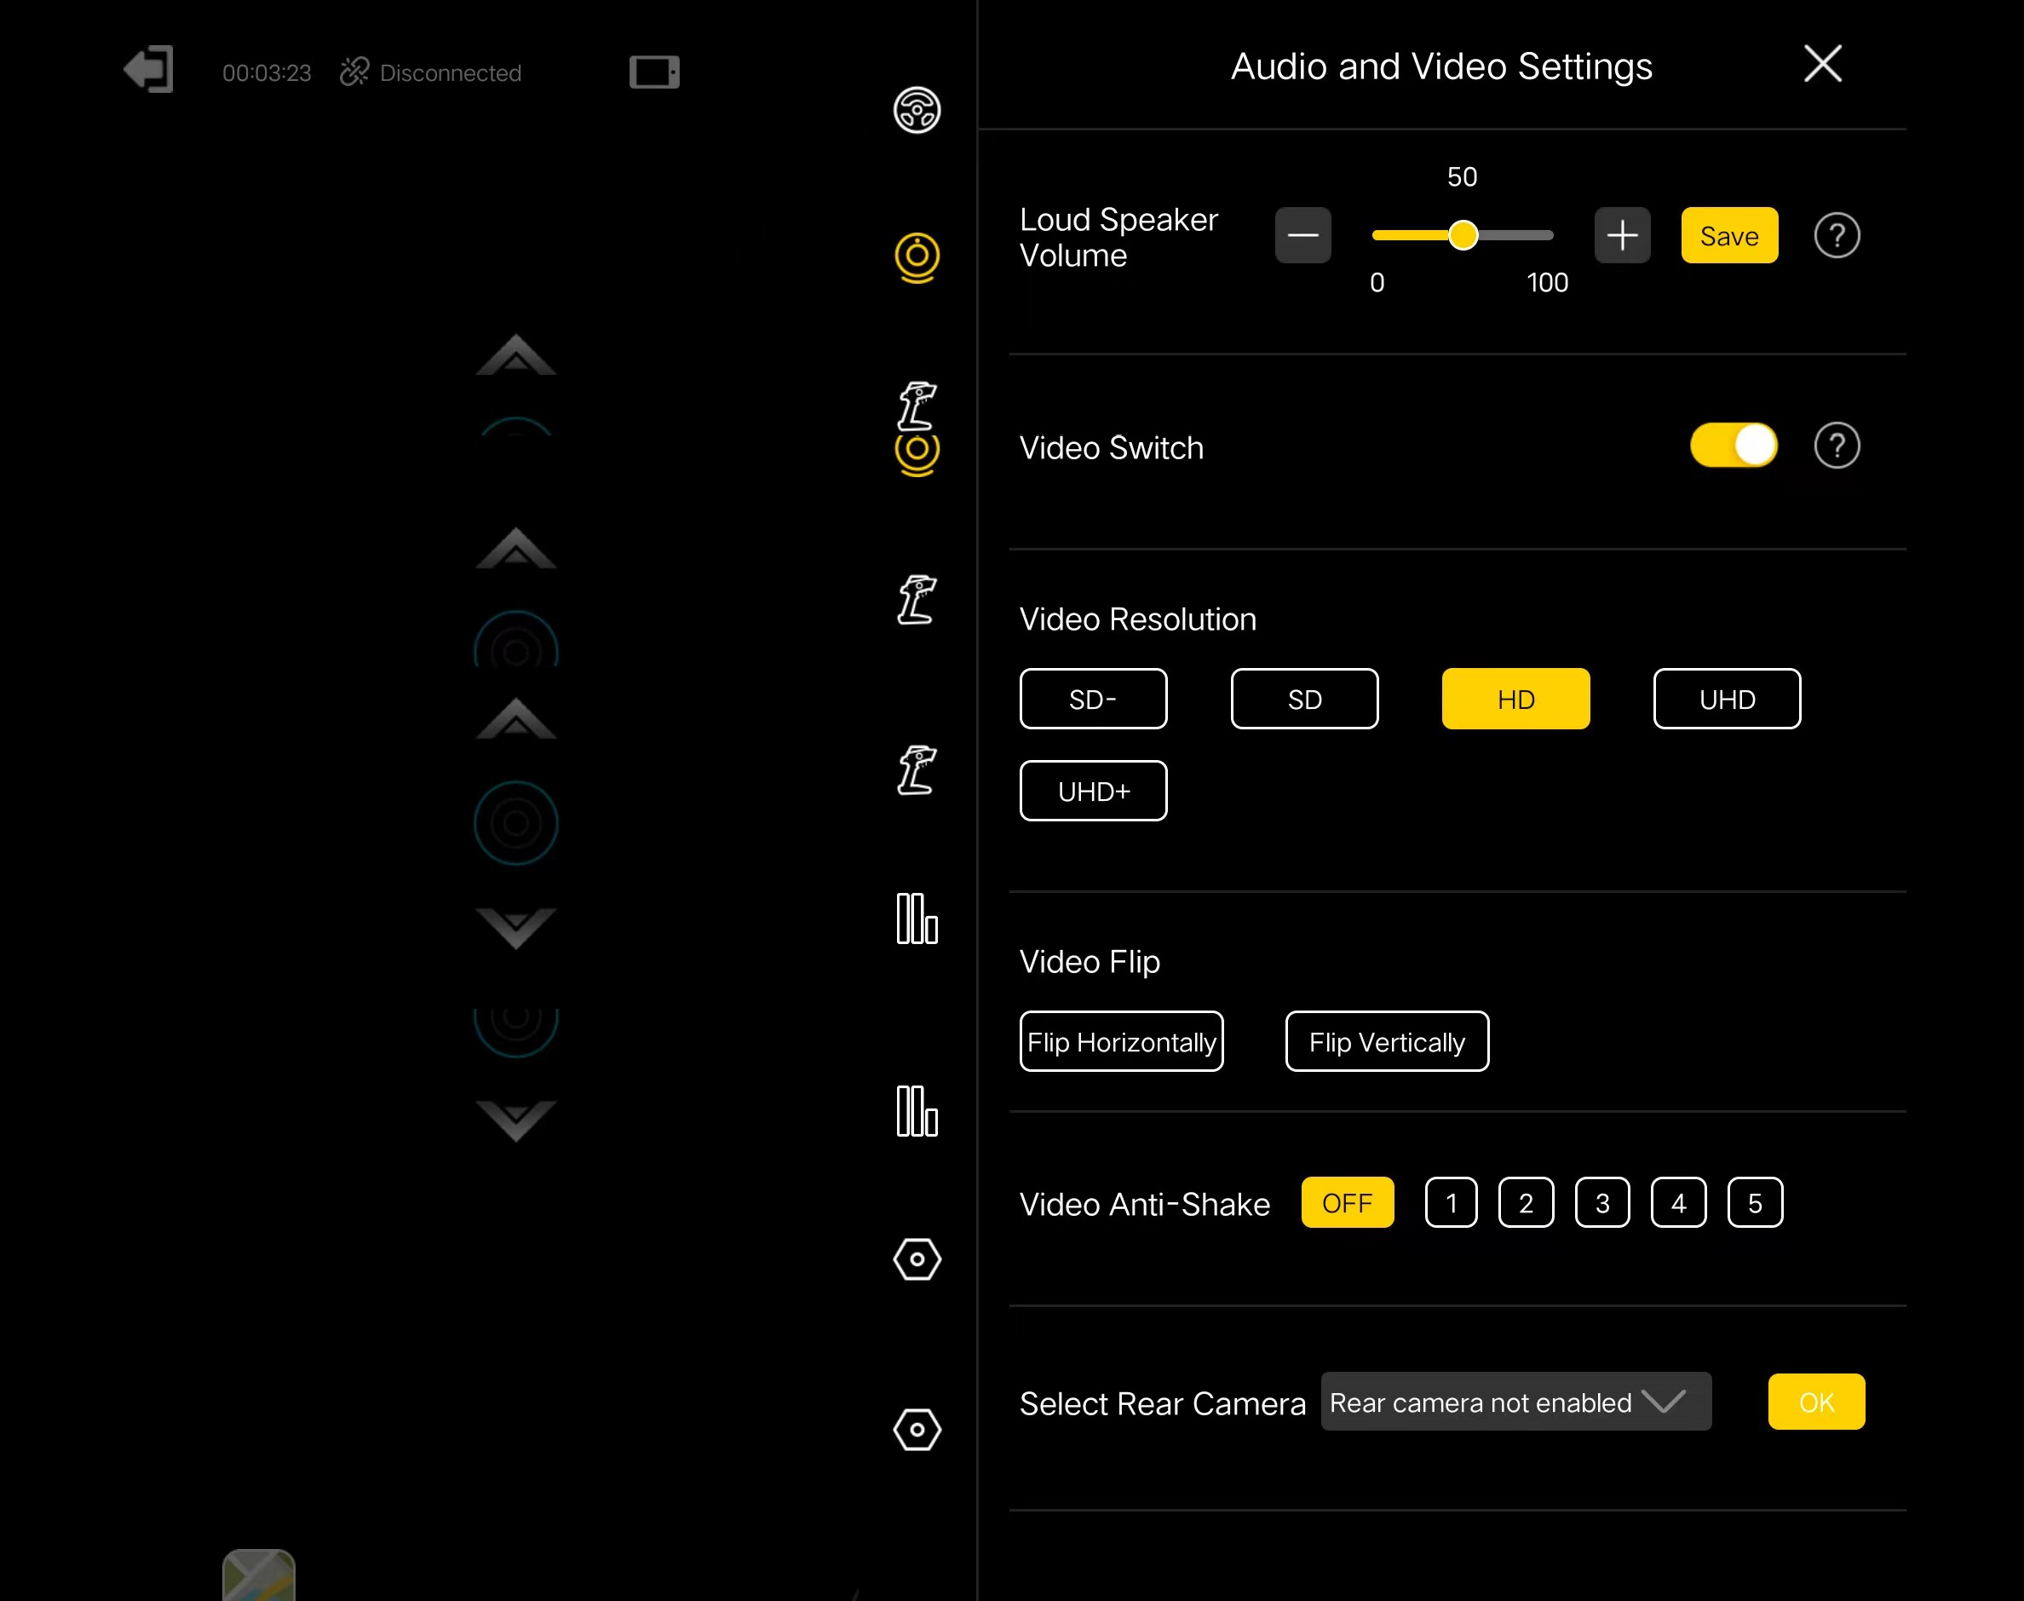

Mobile Network
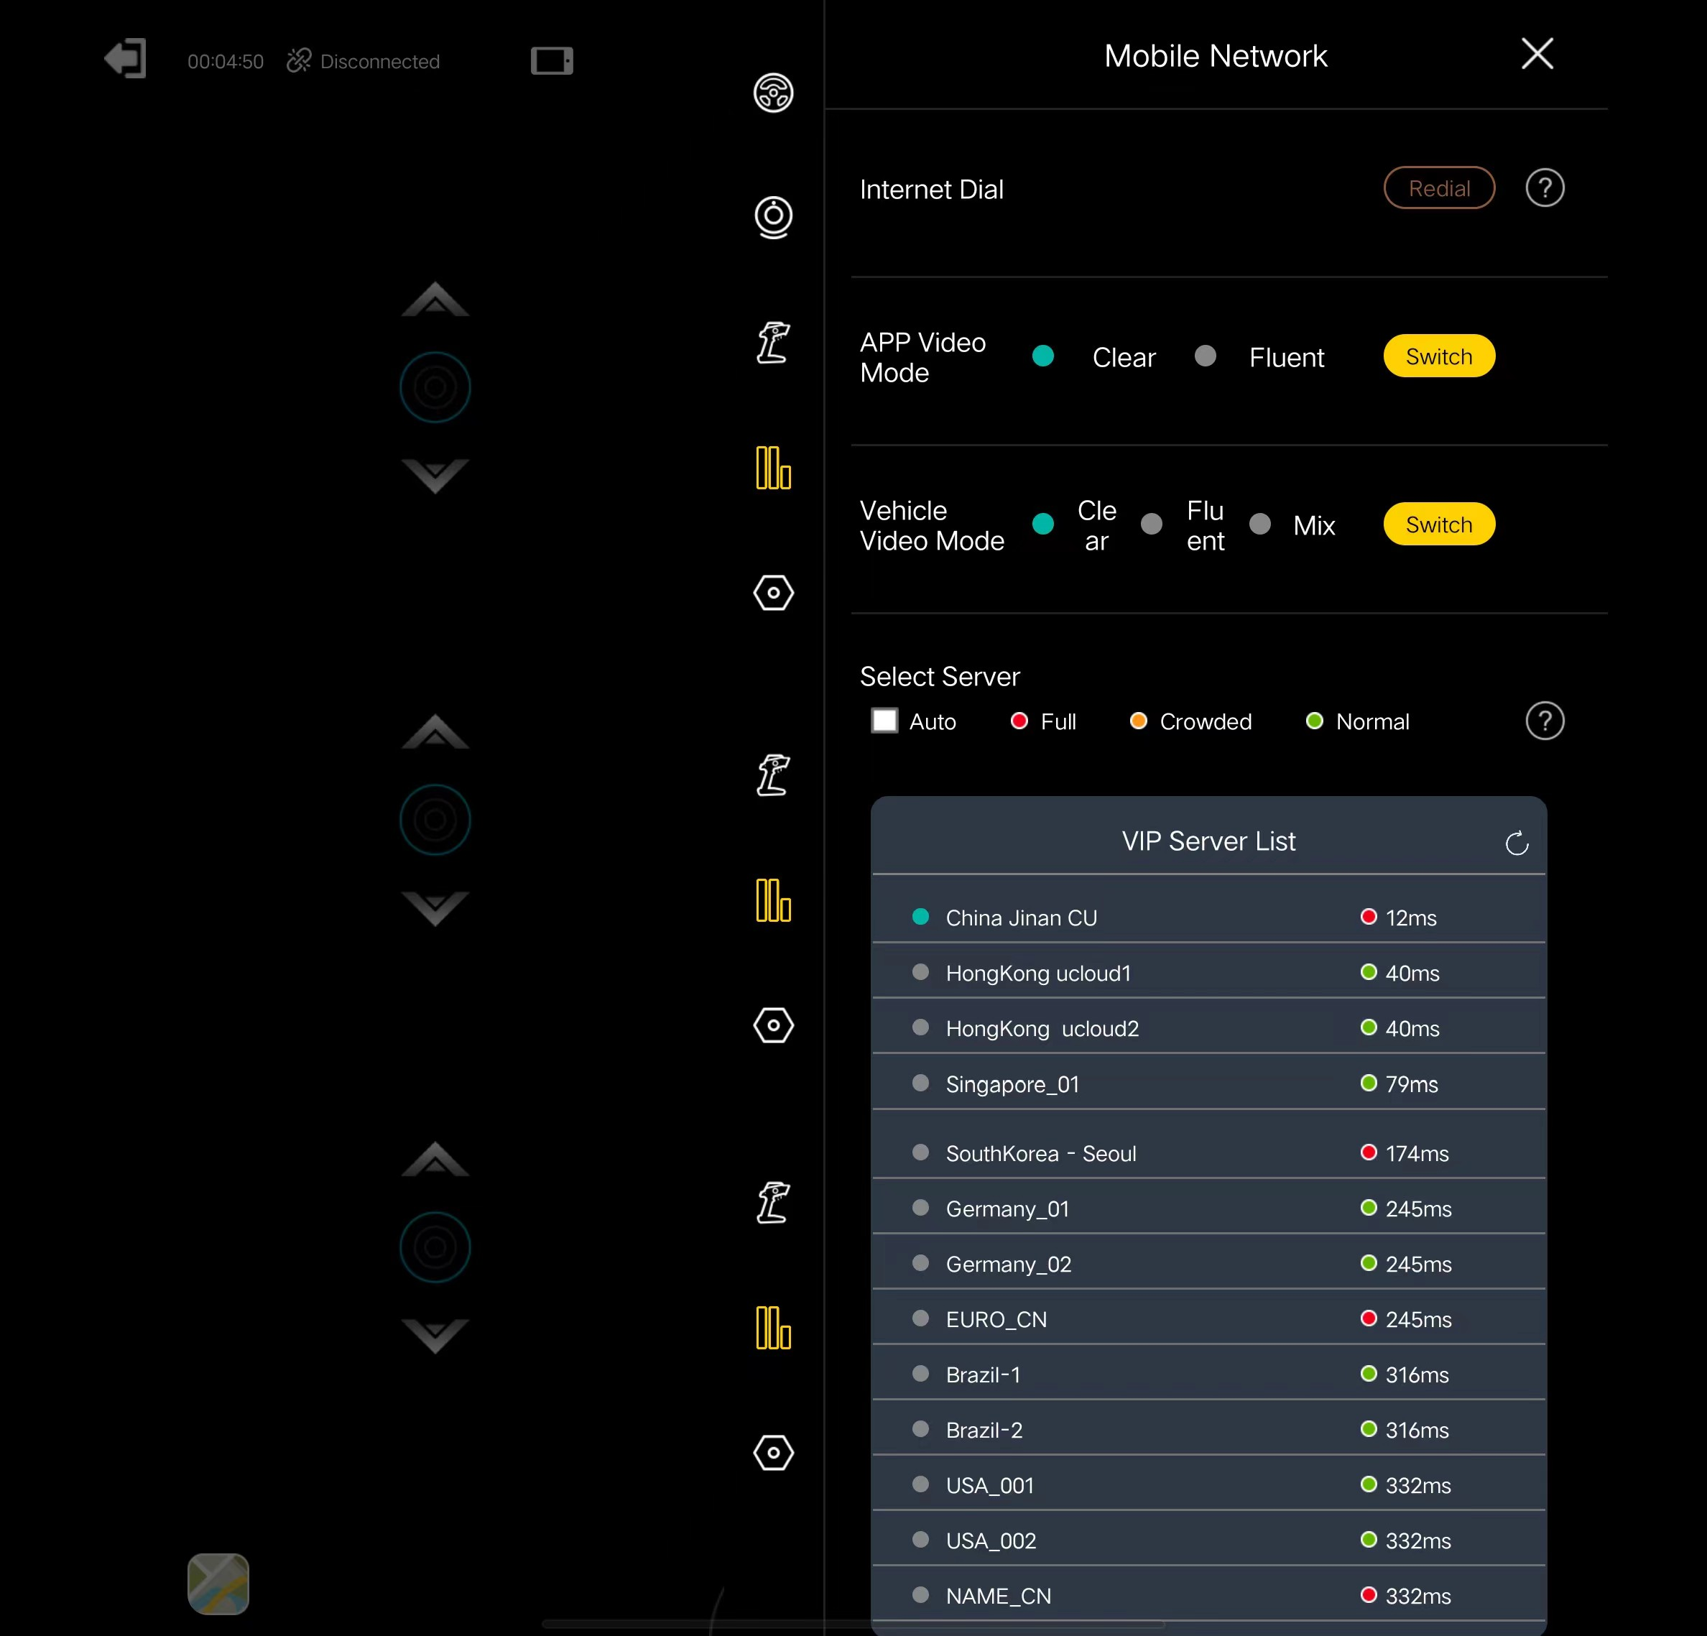

General Settings
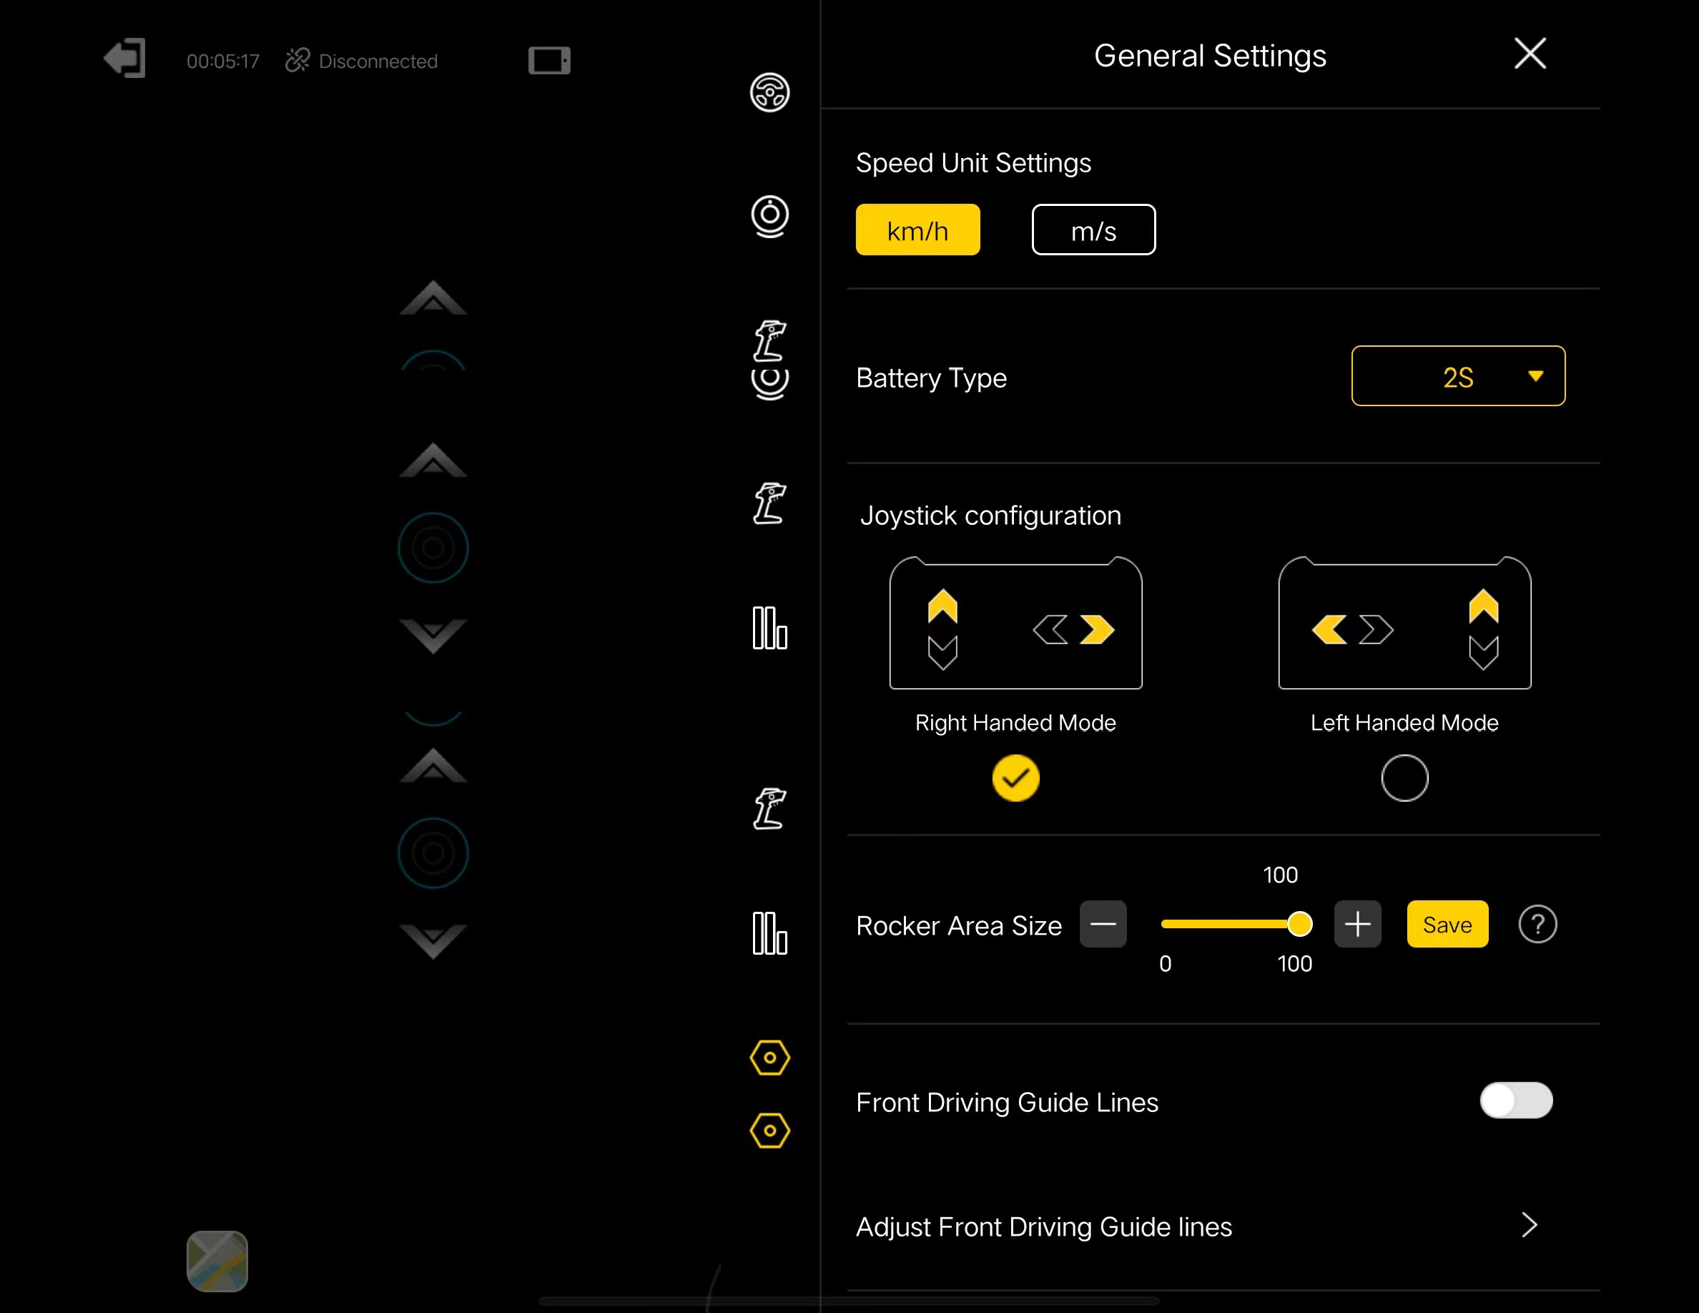

Others

如何驾驶共享车辆

